***UI PATH*** ***Assignment Questions***

Primary Data types and Manipulations

1. Create a List and add 1-10 numbers in List using Loop and Print the List

Answer:

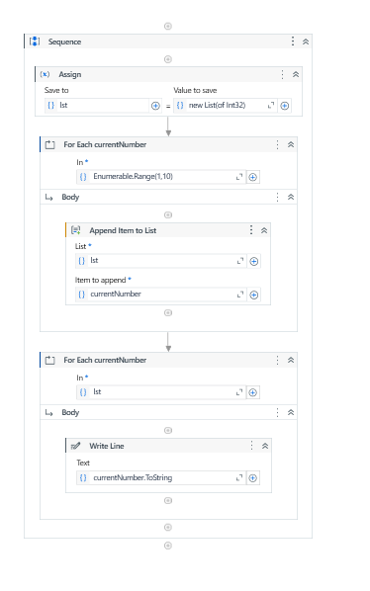

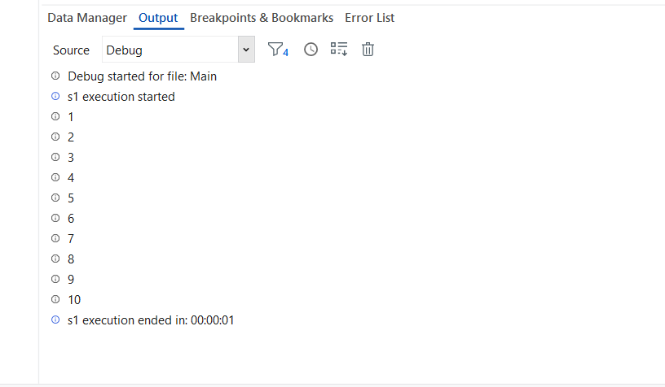

1. Create a Datatable and Print the Row Count. Increment the Value till the Value is not equal to 10 using Do while loop.

Answer: 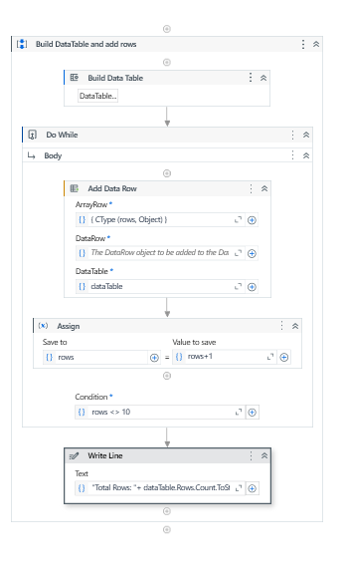

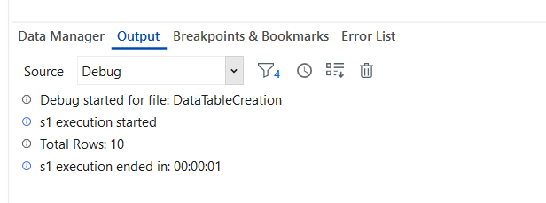

1. Create a Dictionary for a class having 5 students and print the Marks obtained. for each student

Answer: 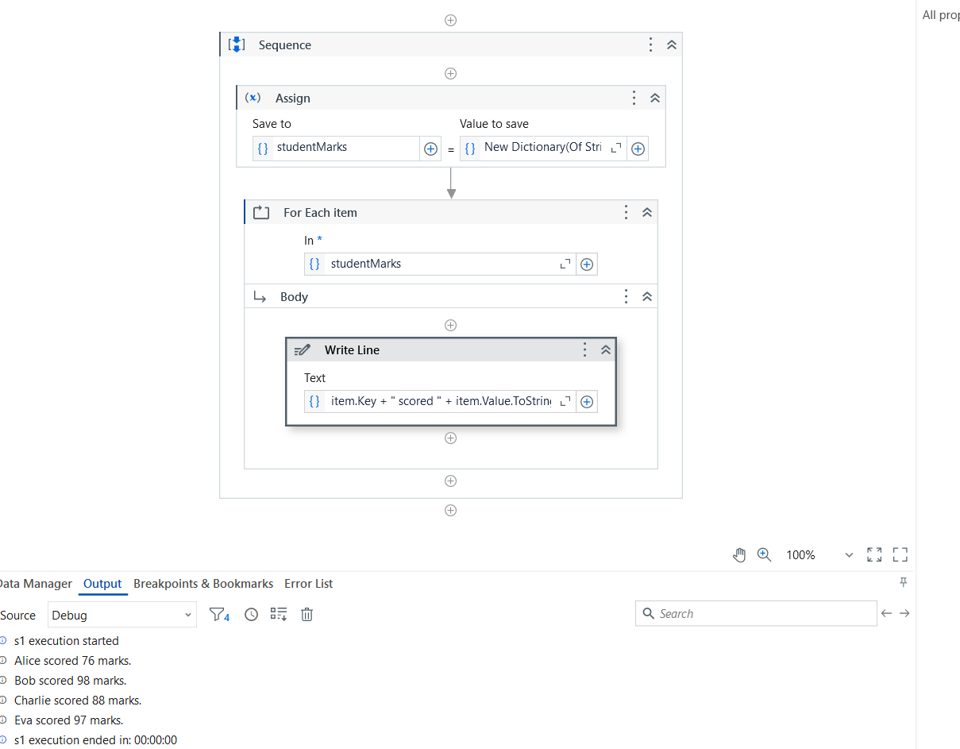

1. Consider a string H;e!llo;Eve;ry;one! and Print the output as - Hello Everyone.

Answer: 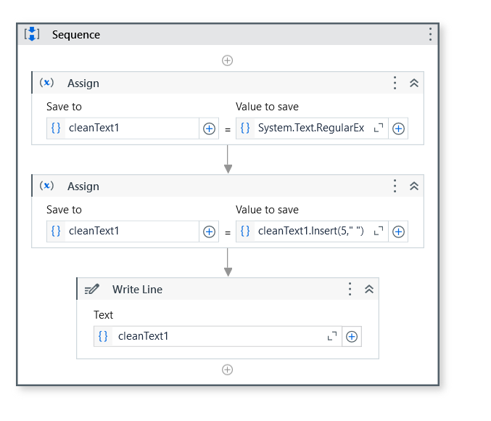

Automation Activities

Activity 1

1. Open browser, search "Java" and print the text of the first URL. Return to Home page and now search "Selenium", click on the first URL.

Answer: 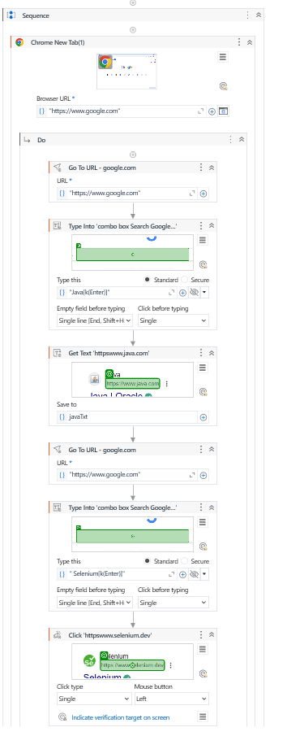

1. Create three different sequences files:

* seq file 1 - Ask the user to input Full Name
* seq file 2 - Ask the user to input Age
* seq file 3 - Reuse the first two sequence files and print the first name of the user, also check if the user is an eligible voter or not.

Answer: 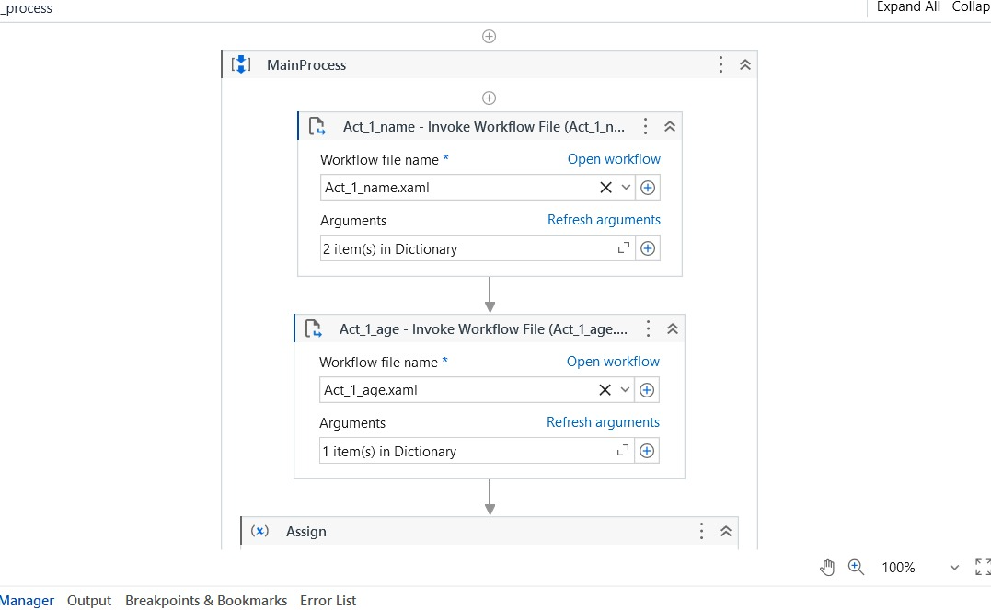

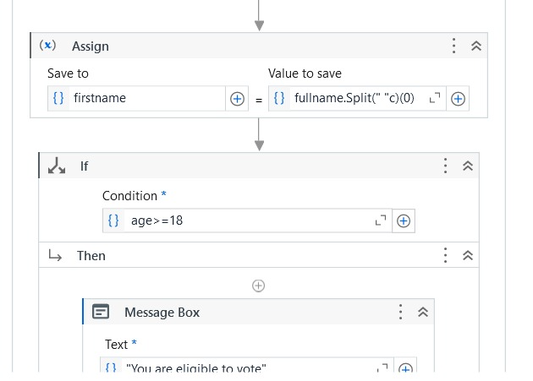

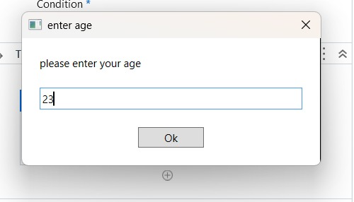

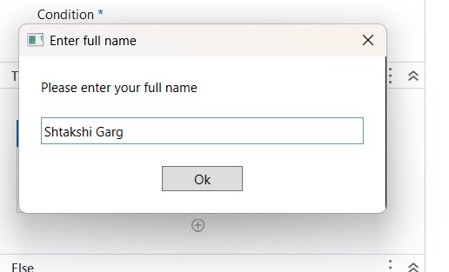

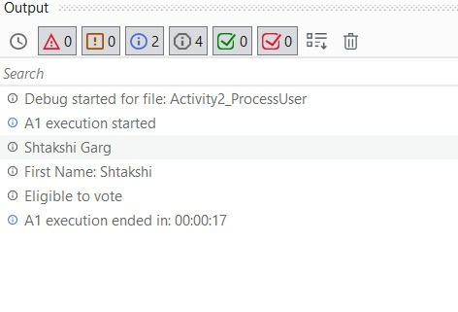

Activity 2

1. Download and save the attached excel at some location.

[Financial Sample](https://geminisolutionsindpvtltd-my.sharepoint.com/:x:/g/personal/raja_arora_geminisolutions_com/ETg-NFj_gatKtWmwByyitOMB1qM_P7c--W6FPpDI8QIuqQ?e=dAIdPi)

1. Open the excel and read the content.
2. Find the highest sale made by the country each year.

Example - In year 'YYYY' company 'xyz' made highest sale of $ 202.

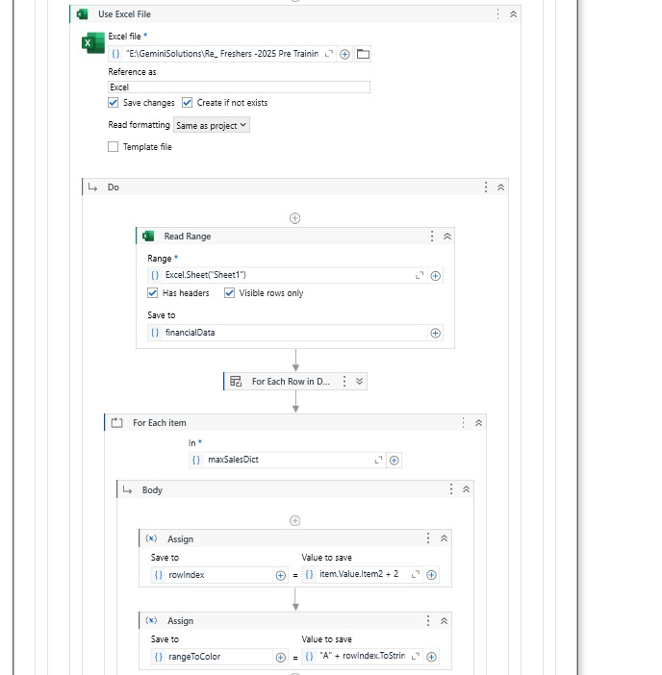

1. Once you have identified the highest sale. Highlight the complete row in red color.
2. Find all the unique country name and Segment and store it in a separate excel Sheet.

**Expectation -**

1. Workflow should be reusable.

2. Variable name should be in lower camelCase.